

DEPLOYING A NODE.JS CRICKET TURF BOOKING APPLICATION USING AWS EC2 INSTANCE

Guided By: Submitted by:
Mrs Bethala Sumana Pavani Golla - 23KT1A0577
Navadeepa Pamarthi - 23KT1A05B4
Maramreddy Triveni - 23KT1A05A1
Bharath Kandiri - 23KT1A0583
Raparthi Bhavana naganjali - 23KT1A0585

Table of Contents
1.Acknowledgement
2.Abstract
3.Introduction
4.Problem Statement
5.Objectives
6.Existing System
7.Proposed System
8.System Architecture
9.Technologies Used
10.AWS EC2 Deployment Architecture
11.Implementation Flow
12.System Modules
13.Results
14.Future Scope
15.Conclusion
16.References

ACKNOWLEDGEMENT
We sincerely express our gratitude to our Principal, Head of the Department, project guide, and faculty members for their valuable suggestions, continuous encouragement, and guidance throughout the development of our project. Their support helped us successfully complete the project titled "Deploying a Node.js Cricket Turf Booking Application Using AWS EC2 Instance." We also thank our parents, friends, and classmates for their constant motivation and cooperation during the project.
We would like to acknowledge the open-source development community for providing excellent technologies and tools, including Node.js, Express.js, HTML, CSS, JavaScript, Bootstrap, Git, and Amazon Web Services (AWS EC2), which greatly simplified the development and deployment of our Cricket Turf Booking application.

ABSTRACT
The Cricket Turf Booking Application is a web-based system developed to simplify the process of booking cricket turf slots online. The application enables users to register, log in, browse available turfs, book preferred time slots, and view their booking history, while administrators can efficiently manage turfs and bookings. The system is developed using Node.js, Express.js, HTML, CSS, JavaScript, and Bootstrap, with JSON used for local data storage. The application is deployed on an AWS EC2 instance, providing secure cloud hosting and remote accessibility. This project demonstrates the practical implementation of cloud-based web application deployment, offering an efficient, user-friendly, and cost-effective solution for cricket turf booking management.

INTRODUCTION
With the rapid growth of web technologies and cloud computing, online booking systems have become an efficient solution for managing sports facilities. The Cricket Turf Booking Application is designed to simplify the process of reserving cricket turf slots by allowing users to register, log in, browse available turfs, and book their preferred time slots through a user-friendly web interface. The application also provides an administrator dashboard to manage turf information and customer bookings effectively.
The project is developed using Node.js and Express.js for the backend, with HTML, CSS, JavaScript, and Bootstrap for the frontend. Instead of using a traditional database, the application stores data in JSON files, making it lightweight and easy to manage. To ensure secure and reliable access over the internet, the application is deployed on an Amazon Web Services (AWS) EC2 instance. This project demonstrates the practical implementation of a cloud-hosted web application while improving the efficiency, accessibility, and management of cricket turf bookings.

PROBLEM STATEMENT
The increasing demand for sports facilities has highlighted the need for an efficient and reliable online booking system. Conventional turf booking methods often involve manual coordination, leading to delays, scheduling conflicts, and difficulty in tracking reservations. Moreover, the absence of a centralized online platform makes it challenging for users to check turf availability and for administrators to manage bookings effectively. This project addresses these issues by developing a Node.js-based Cricket Turf Booking Application and deploying it on an AWS EC2 instance, enabling users to access the application from anywhere, reserve available slots conveniently, and allowing administrators to manage turf bookings through a secure and cloud-hosted platform.

OBJECTIVES
- To develop a web-based Cricket Turf Booking Application using Node.js.
- To provide secure user registration and login.
- To enable users to browse and book available cricket turf slots online.
- To provide an admin dashboard for managing turfs and bookings.
- To deploy the application on an AWS EC2 instance for secure and reliable cloud access.
- To improve the efficiency and convenience of the turf booking process.
EXISTING SYSTEM
The existing cricket turf booking process mainly depends on phone calls, direct visits, or manual record maintenance. Customers must contact the turf management to check slot availability and reserve a booking. This approach is time-consuming, prone to booking conflicts, lacks real-time updates, and makes it difficult for administrators to manage customer and booking records efficiently.
Manual Turf Booking Process
Customer
↓
Contacts Turf Manager
↓
Checks Slot Availability
↓
Books Turf Manually
↓
Booking Confirmation
PROPOSED SYSTEM
The proposed system is a web-based Cricket Turf Booking Application developed using Node.js and deployed on an AWS EC2 instance. It enables users to register, log in, browse available cricket turfs, check slot availability, and book their preferred time slots online. The application also provides an administrator dashboard to manage turfs, bookings, and users efficiently. By hosting the application on AWS EC2, the system offers secure, reliable, and remote access while reducing manual effort and improving the overall booking experience.
Online Turf Booking Process
User
↓
Registers / Logs In
↓
Browses Available Turfs
↓
Selects Date & Time Slot
↓
Books Turf Online
↓
Booking Confirmation

SYSTEM ARCHITECTURE

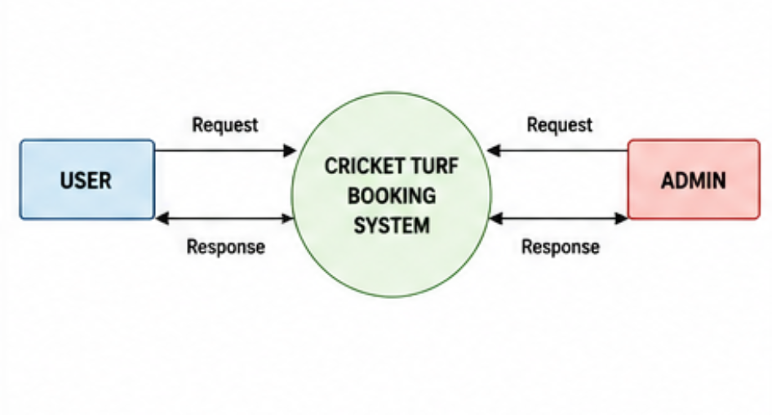
TECHNOLOGIES USED

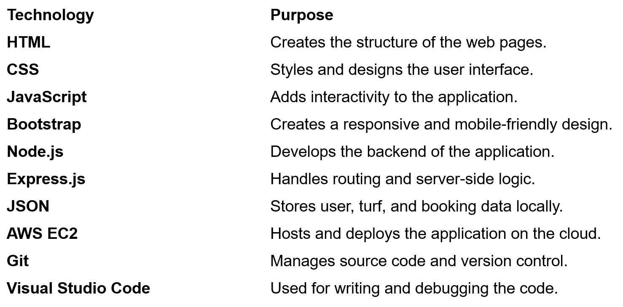
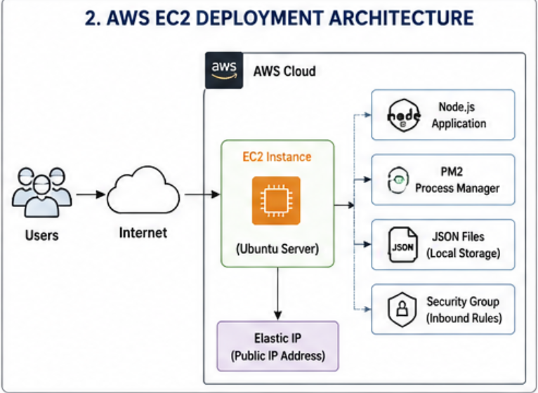

IMPLEMENTATION FLOW
Start
↓
Open Cricket Turf Booking Application
↓
User Registration / Login
↓
User Authentication
↓
Browse Available Cricket Turfs
↓
Select Turf
↓
Choose Date & Time Slot
↓
Check Slot Availability
↓
Confirm Booking
↓
Store Booking Details (JSON)
↓
Update Booking History
↓
Admin Manages Turfs & Bookings
↓
Deploy Application on AWS EC2
↓
Access Application via Public IP
↓
Display Booking Confirmation
↓
End
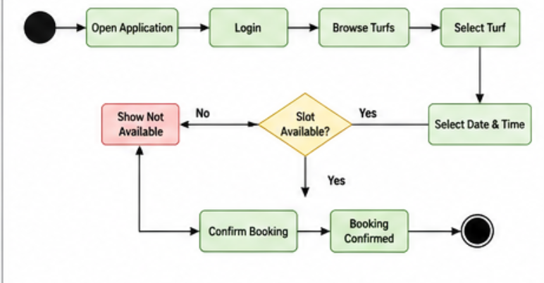

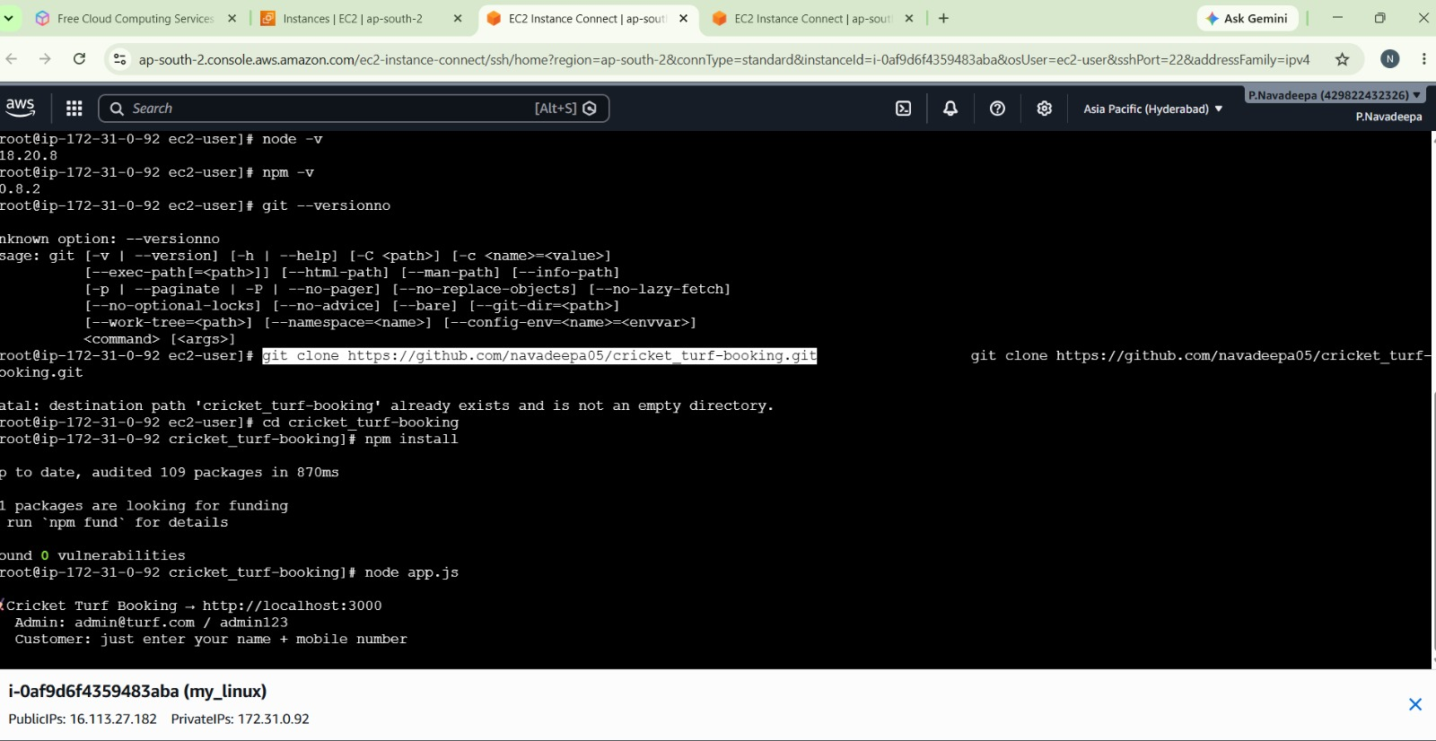
SYSTEM MODULES
Module 1: User Registration and Login
Functions:
- Register a new user account.
- Login using valid credentials.
- Logout securely from the application.

Module 2: Browse Cricket Turfs
Functions:
- View the list of available cricket turfs.
- Search for turfs based on location or availability.
- Select a preferred turf for booking.

Module 3: Slot Booking
Functions:
- Choose the booking date.
- Select an available time slot.
- Confirm the booking and store the booking details.

Module 4: Booking History
Functions:
- View previous and current bookings.
- Check the booking status.

Module 5: Admin Dashboard
Functions:
- View the system dashboard.
- Monitor booking statistics.
- View registered users.

Module 6: Turf Management
Functions:
- Add new cricket turfs.
- Edit existing turf details.
- Delete unavailable or inactive turfs.

Module 7: Booking Management
Functions:
- View all booking requests.
- Approve booking requests.
- Cancel or reject bookings when necessary.

Module 8: AWS EC2 Deployment
Functions:
- Deploy the Node.js application on an AWS EC2 instance.
- Configure the server and required software packages.
- Access the application using the EC2 public IP address.

RESULTS
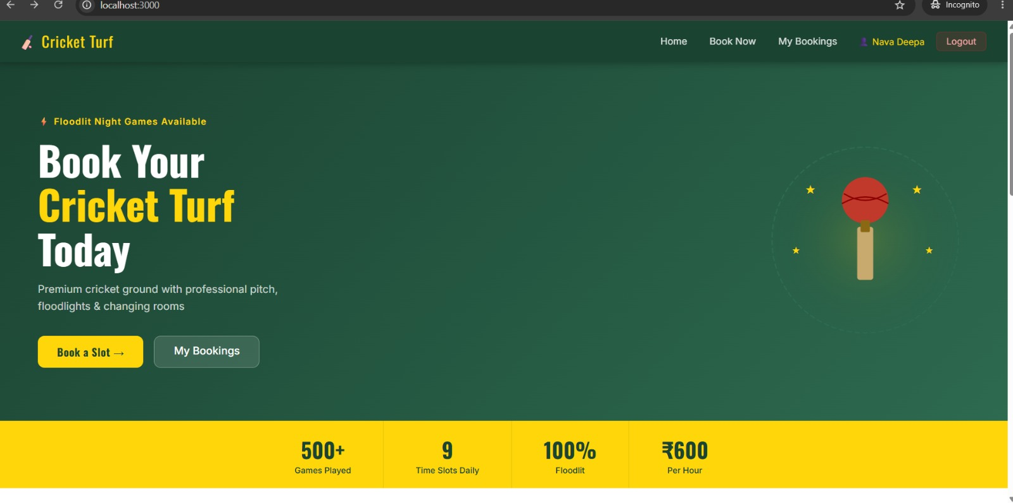

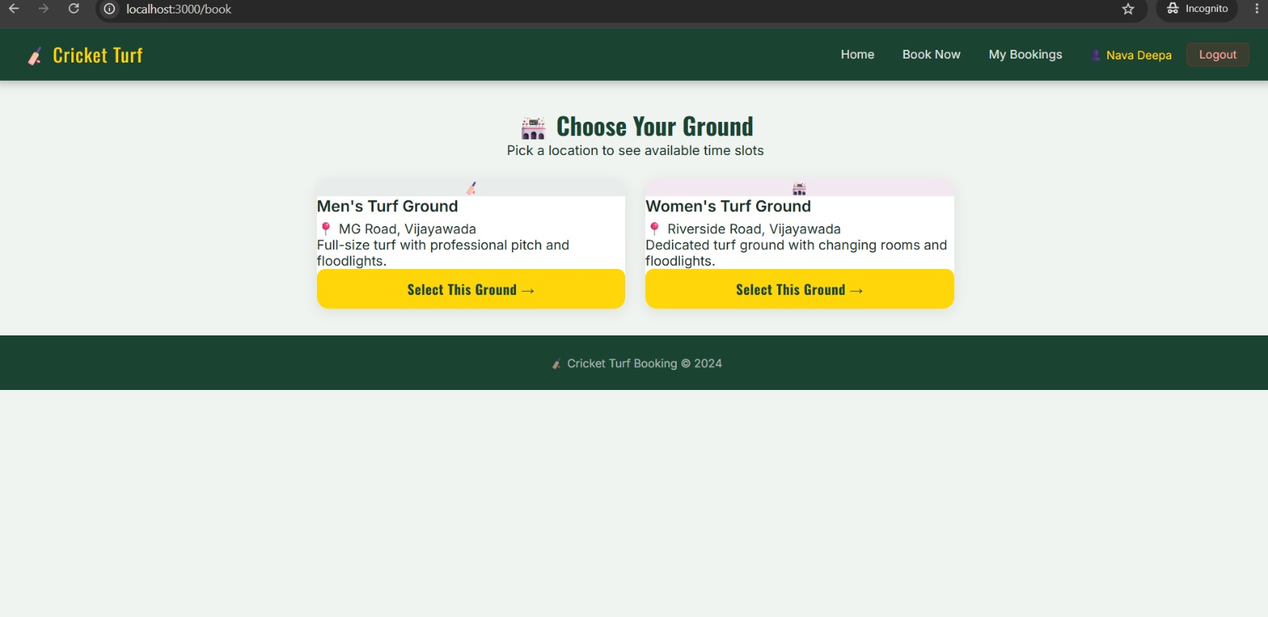
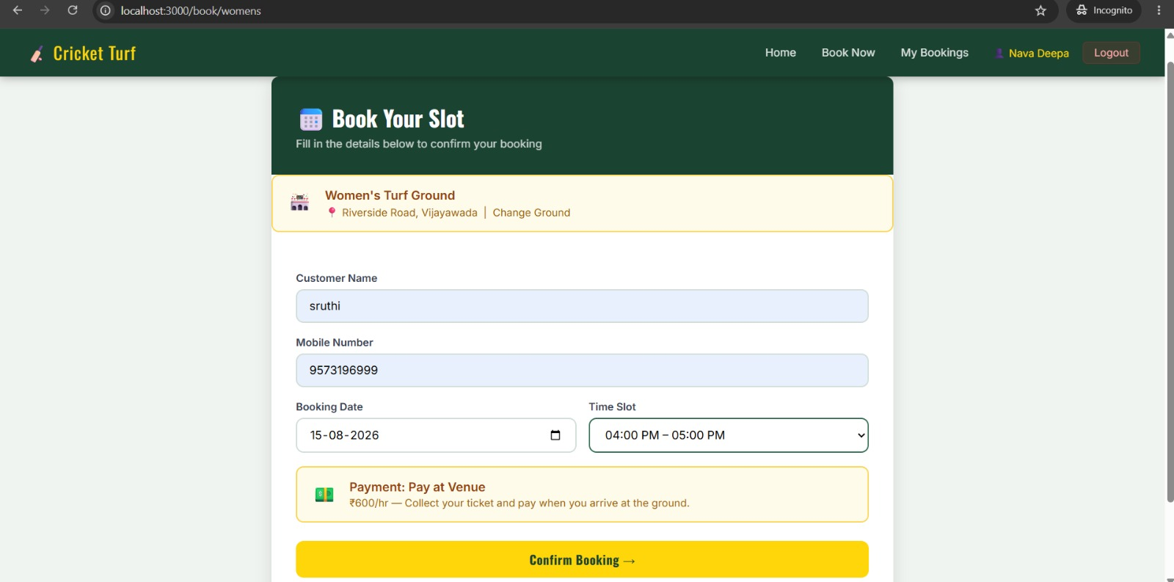

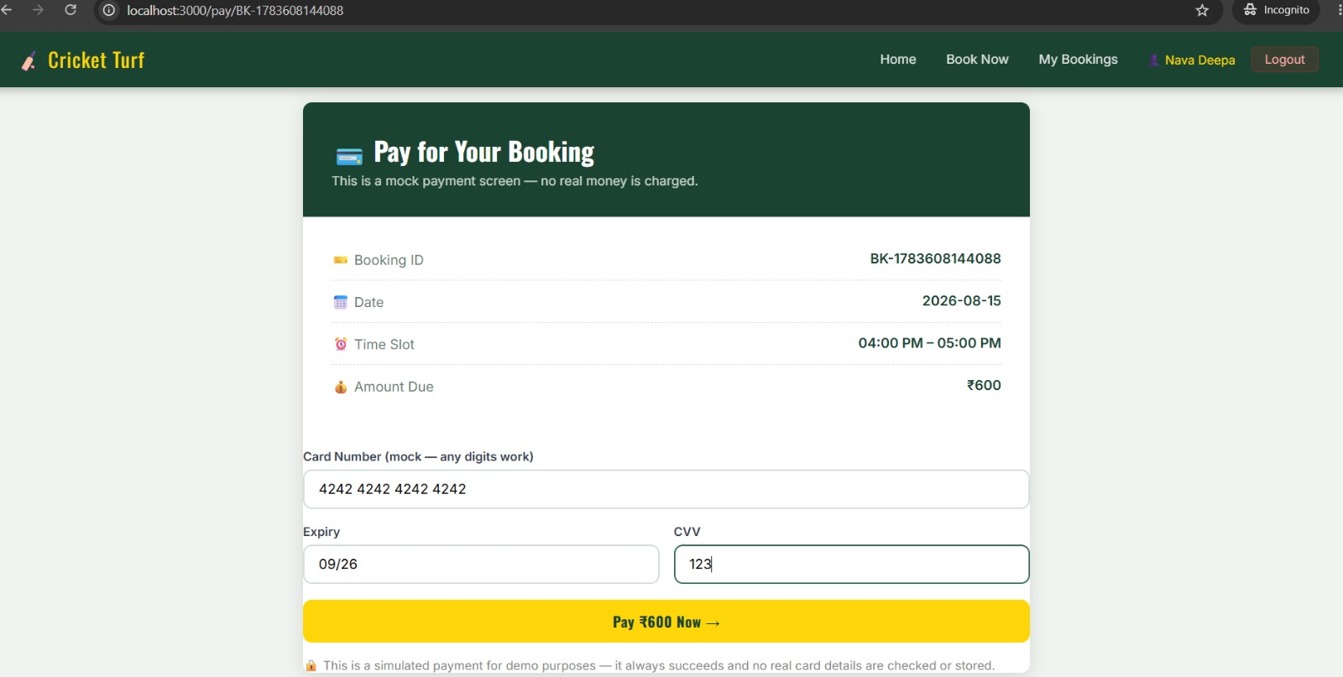

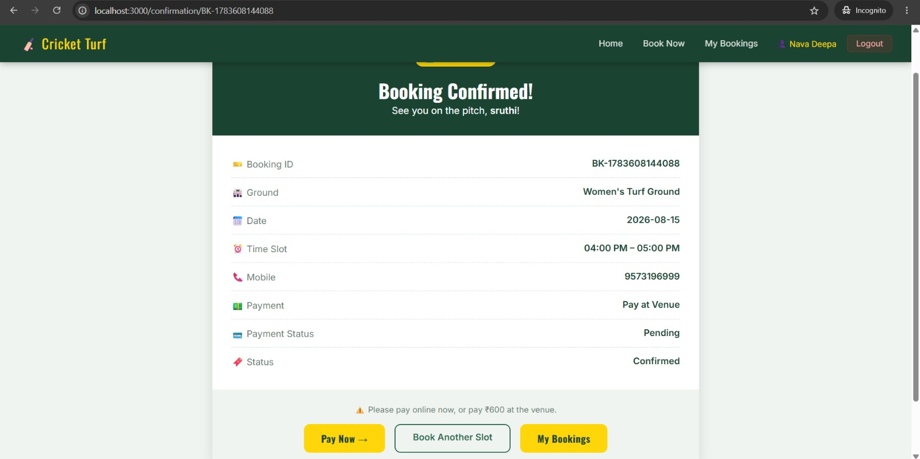

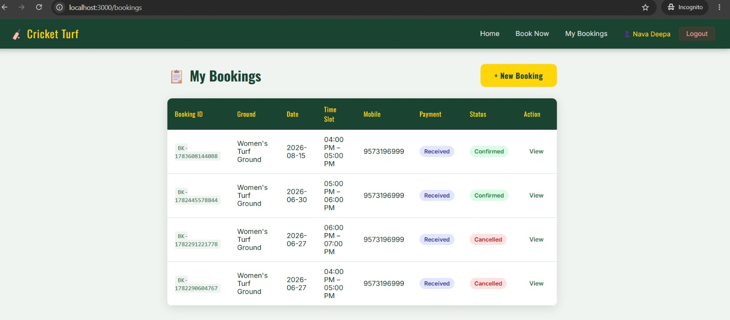
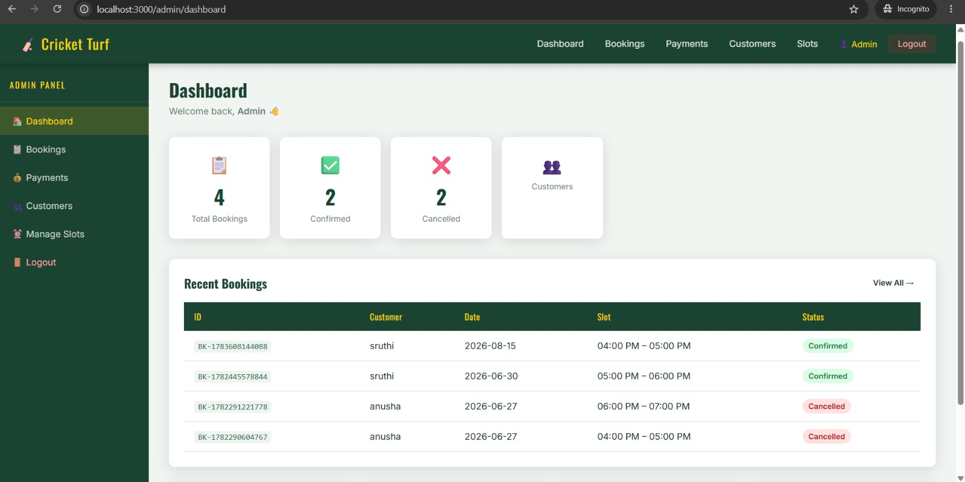

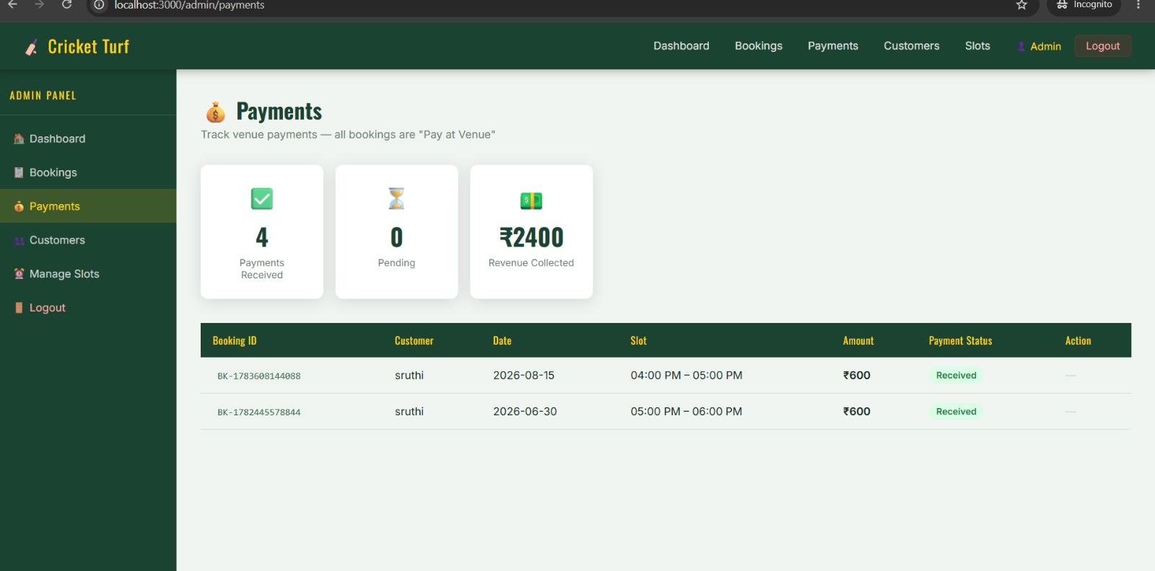
FUTURE SCOPE
- Integrate a MySQL or MongoDB database instead of JSON for better scalability.
- Add online payment gateways such as UPI, Razorpay, or Stripe.
- Develop a mobile application for Android and iOS users.
- Implement email and SMS notifications for booking confirmations and reminders.
- Add real-time slot availability and advanced search features to improve the user experience

CONCLUSION
The Node.js Cricket Turf Booking Application provides a simple, efficient, and user-friendly solution for managing cricket turf reservations online. The system allows users to register, log in, browse available turfs, book preferred time slots, and view their booking history. It also includes an administrator dashboard for managing turfs, users, and bookings, reducing the manual effort involved in traditional booking methods and minimizing scheduling
The application was successfully developed using HTML, CSS, JavaScript, Bootstrap, Node.js, and Express.js, with JSON used for data storage. It was deployed on an AWS EC2 instance, enabling secure and reliable cloud-based access from anywhere with an internet connection. Overall, the project demonstrates the effective use of modern web technologies and cloud computing to build a practical, scalable, and accessible online booking system, improving both user convenience and administrative efficiency.
.
REFERENCES
- Node.js Official Documentation – https://nodejs.org/docs
- Express.js Official Documentation – https://expressjs.com/
- Amazon Web Services (AWS EC2) Documentation – https://docs.aws.amazon.com/ec2/
- Bootstrap Documentation – https://getbootstrap.com/docs/
- MDN Web Docs (HTML, CSS, JavaScript) – https://developer.mozilla.org/
- Git Documentation – https://git-scm.com/doc

